***MotoGP –part 2***

In the second part of the exercise, we will create the tables for the *MotoGP* website. The data model you need to create looks like this:

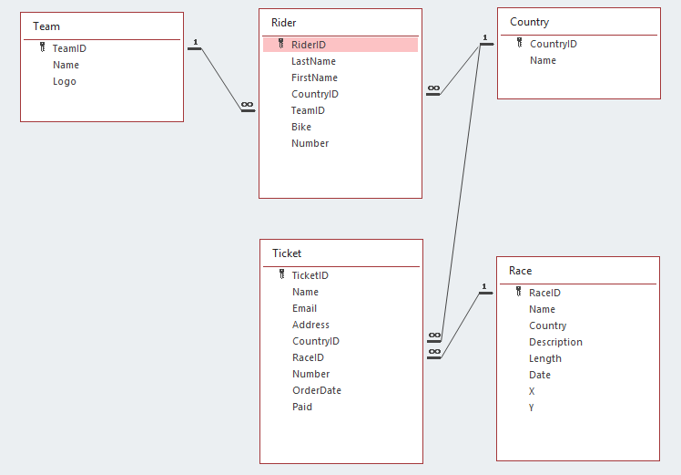

You must complete the *Race* class from the previous exercise.

Most data types are strings. Except of course the *Primary* and *Foreign Keys*, which are *ints*. Also *Number* (in *Rider*), *Length*, *X* and *Y* (in *Race*) are *ints*. *Date* and *OrderDate* are of course *Datetimes*. Finally *Paid* is a *bool*.

The *Primary Keys* are all auto-numbering except *Country* and *Team* (see Powerpoint).

When creating the classes, make sure you not only provide the *Foreign Key* fields, but also the *Navigation Properties*. This is very important. Otherwise you will have problems reading the data later.

Make sure the tables in the database are created in the singular (naming conventions). The names of the *DBSets* in the database context are plural. The database context class is called *GPContext.cs*.

The *DBInitializer* class can be found in the resources. If you have done all the above correctly, this class should not have any errors when you add it to your project.

If you configure everything else properly, then when you start the application *EF* generates a database for you with a table for each *Model* containing the test data from the *DBInitializer* class:

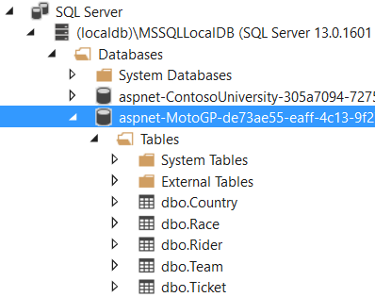

Open the tables and look at the information:

